ICY GRAY LENSES

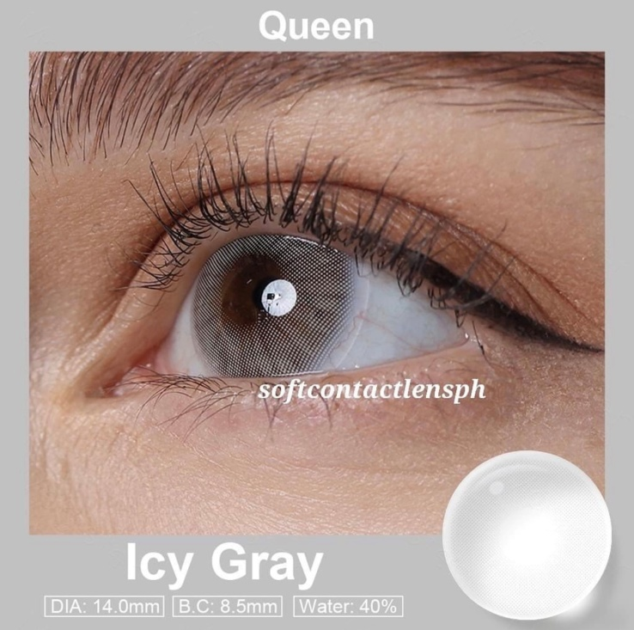

**DIA: 14.0mm**

**B.C: 8.5mm**

**WATER: 40%**

Icy Gray contact lenses are a type of colored contact lenses that feature a cool and light gray color. These lenses are designed to provide a unique and striking appearance by enhancing or changing the natural eye color. Similar to other colored contact lenses, Icy Gray lenses are typically made from soft and breathable materials such as silicone hydro gel. These materials allow for comfortable wear and ensure proper oxygen flow to the eyes. It is important to note that contact lenses, including Icy Gray ones, should be prescribed and fitted by a qualified eye care professional. They will assess your eye health, provide a proper fitting, and guide you on the safe and appropriate use of these lenses based on your individual needs and eye condition. Proper care and maintenance of Icy Gray contact lenses are essential to ensure their longevity and your eye health. Follow the instructions provided by the manufacturer or your eye care professional for cleaning, storing, and replacing the lenses. Remember, it is always recommended to consult with an eye care professional before using any contact lenses, including Icy Gray ones. They can provide personalized advice and ensure that the lenses are suitable for your eyes.